|  |  |  |  |
| --- | --- | --- | --- |
| **Ex. No. 05** | **Finite Automata** | | |
| Date of Exercise | _____________ | Date of Output Verification | _____________ |

**Question**

Write a program to simulate DFA.

**Program**

import java.io.*;

import java.util.*;

//@author William Scott

public class CompilerLabExp5DeterministicFiniteAutomata {

//UR12CS135 - P.William Scott - Exp 5 - Finite Automata

public static BufferedReader br;

public static String ts, tt[], ip;

public static char table[][] = new char[3][10], startstate, finalstate, nextstate;

public static int t = 0;

public static Scanner in = new Scanner(System.in);

public static void main(String[] args) throws FileNotFoundException, IOException {

System.out.println("UR12CS135 - DFA");

readfile();

ip = "aaaab";

System.out.println("\nInput String: " + ip + "\n");

verifystring();

}

public static void readfile() throws FileNotFoundException, IOException {

System.out.println("\n-----Input File-------");

br = new BufferedReader(new FileReader("..\\Exp 5 - Finite Automata Input File.txt"));

ts = br.readLine();

tt = ts.split(" ");

startstate = tt[0].charAt(0);

finalstate = tt[1].charAt(0);

System.out.println("Start State: " + startstate + "\nFinal State: " + finalstate + "\nTranstiton Table");

while ((ts = br.readLine()) != null) {

System.out.println(ts);

tt = ts.split(" ");

table[0][t] = tt[0].charAt(0);

table[1][t] = tt[1].charAt(0);

table[2][t] = tt[2].charAt(0);

t++;

}

}

public static void verifystring() {

int h = 0;

for (char c : ip.toCharArray()) {

if (h == 0) {

getnextstate(startstate, c);

} else {

getnextstate(nextstate, c);

}

h = 1;

}

if (nextstate == finalstate) {

System.out.println("Accpted!");

} else {

System.out.println("Not Accepted!");

}

}

public static void getnextstate(char a, char b) {

int h = 0;

for (int i = 0; i < t; i++) {

if (a == table[0][i] && table[1][i] == b) {

nextstate = table[2][i];

h = 1;

}

}

if (h == 0) {

nextstate = ' ';

}

System.out.println(" " + a + " " + b + " " + nextstate);

}

}

**Output**

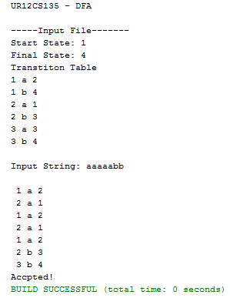

**Input**

*Exp 5 - Finite Automata Input File.txt*

1 4

1 a 2

1 b 4

2 a 1

2 b 3

3 a 3

3 b 4

Input String: aaaaabb

**Result**

DFA is successfully simulated in java.

[Signature of the Staff In-charge]

Name of the Staff In – charge: Mr. Jeban Chandir Moses

Date: ____________